

T.C.

Toros University

Faculty of Engineering

Department of Computer and Software Engineering

Python Final Project

Regression

Burhan Yaşbay - 195050027

05.07.2022

**Introduction**

**What is Regression:**

Regression is a statistical method used in finance, investing, and other disciplines that attempts to determine the strength and character of the relationship between one dependent variable (usually denoted by Y) and a series of other variables (known as independent variables).

**What is Dataset:**

A data set is a collection of numbers or values that relate to a particular subject. For example, the test scores of each student in a particular class is a data set.

**Random Forest Regression**

Random Forest Regression is a supervised learning algorithm that uses ensemble learning method for regression. Ensemble learning method is a technique that combines predictions from multiple machine learning algorithms to make a more accurate prediction than a single model.

Random forest is a type of supervised learning algorithm that uses ensemble methods (bagging) to solve both regression and classification problems. The algorithm operates by constructing a multitude of decision trees at training time and outputting the mean/mode of prediction of the individual trees.

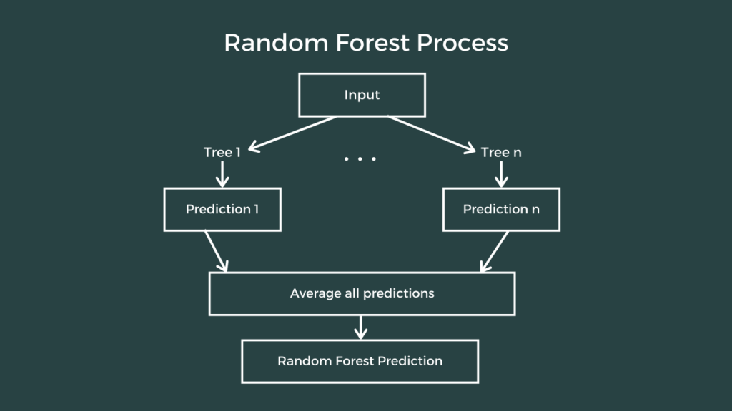

The fundamental concept behind random forest is the wisdom of crowds wherein a large number of uncorrelated models operating as a committee will outperform any of the individual constituent models.

The reason behind this is the fact that the trees protect each other from their individual errors. Within a random forest, there is no interaction between the individual trees. A random forest acts as an estimator algorithm that aggregates the result of many decision trees and then outputs the most optimal result.

**Decision Tree Regression**

Decision tree builds regression or classification models in the form of a tree structure. It breaks down a dataset into smaller and smaller subsets while at the same time an associated decision tree is incrementally developed. The final result is a tree with decision nodes and leaf nodes. A decision node has two or more branches, each representing values for the attribute tested. Leaf node represents a decision on the numerical target. The topmost decision node in a tree which corresponds to the best predictor called root node. Decision trees can handle both categorical and numerical data.

The core algorithm for building decision trees called ID3 by J. R. Quinlan which employs a top-down, greedy search through the space of possible branches with no backtracking. The ID3 algorithm can be used to construct a decision tree for regression by replacing Information Gain with Standard Deviation Reduction.

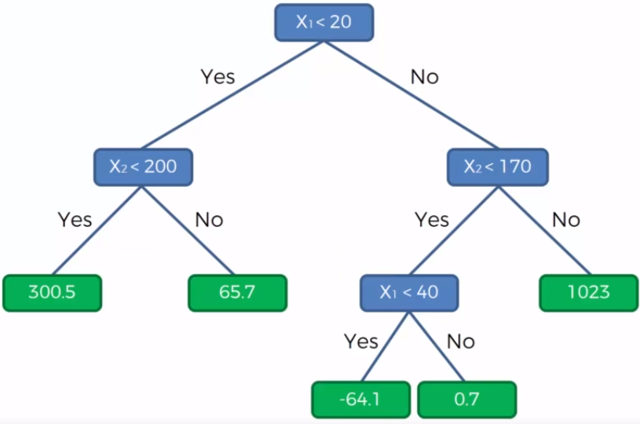

A decision tree is built top-down from a root node and involves partitioning the data into subsets that contain instances with similar values (homogenous). We use standard deviation to calculate the homogeneity of a numerical sample. If the numerical sample is completely homogeneous its standard deviation is zero.

**K Nearest Neighbors**

K nearest neighbors is a simple algorithm that stores all available cases and predict the numerical target based on a similarity measure (e.g., distance functions). KNN has been used in statistical estimation and pattern recognition already in the beginning of 1970’s as a non-parametric technique.

A simple implementation of KNN regression is to calculate the average of the numerical target of the K nearest neighbors. Another approach uses an inverse distance weighted average of the K nearest neighbors. KNN regression uses the same distance functions as KNN classification.

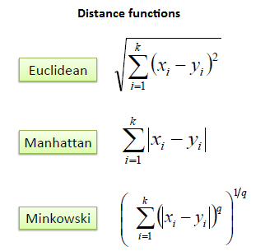

Three distance measures are only valid for continuous variables. In the case of categorical variables you must use the Hamming distance, which is a measure of the number of instances in which corresponding symbols are different in two strings of equal length.

Choosing the optimal value for K is best done by first inspecting the data. In general, a large K value is more precise as it reduces the overall noise; however, the compromise is that the distinct boundaries within the feature space are blurred. Cross-validation is another way to retrospectively determine a good K value by using an independent dataset to validate your K value. The optimal K for most datasets is 10 or more. That produces much better results than 1-NN.

**Evaluation Parameters**

**R2 Score:**

R2 score is a metric that tells the performance of your model, not the loss in an absolute sense that how many wells did your model perform.

In contrast, MAE and MSE depend on the context as we have seen whereas the R2 score is independent of context.

So, with help of R squared we have a baseline model to compare a model which none of the other metrics provides. The same we have in classification problems which we call a threshold which is fixed at 0.5. So basically R2 squared calculates how must regression line is better than a mean line.

Hence, R2 squared is also known as Coefficient of Determination or sometimes also known as Goodness of fit

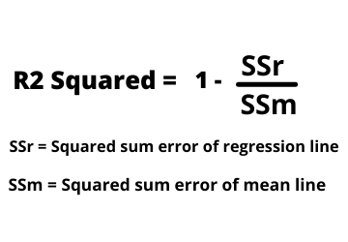

**Mean Absolute Error:**

MAE is a very simple metric which calculates the absolute difference between actual and predicted values.

To better understand, let’s take an example you have input data and output data and use Linear Regression, which draws a best-fit line.

Now you have to find the MAE of your model which is basically a mistake made by the model known as an error. Now find the difference between the actual value and predicted value that is an absolute error but we have to find the mean absolute of the complete dataset.

so, sum all the errors and divide them by a total number of observations And this is MAE. And we aim to get a minimum MAE because this is a loss.

**Mean Squared Error:**

MSE is a most used and very simple metric with a little bit of change in mean absolute error. Mean squared error states that finding the squared difference between actual and predicted value.

So, above we are finding the absolute difference and here we are finding the squared difference.

What actually the MSE represents? It represents the squared distance between actual and predicted values. we perform squared to avoid the cancellation of negative terms and it is the benefit of MSE.

**Libraries**

Pandas is an open source Python package that is most widely used for data science/data analysis and machine learning tasks. It is built on top of another package named Numpy, which provides support for multi-dimensional arrays. As one of the most popular data wrangling packages, Pandas works well with many other data science modules inside the Python ecosystem.

Scikit-learn is a library in Python that provides many unsupervised and supervised learning algorithms. It’s built upon some of the technology you might already be familiar with, like NumPy, pandas, and Matplotlib!

The functionality that scikit-learn provides include:

Regression, including Linear and Logistic Regression

Classification, including K-Nearest Neighbors

Clustering, including K-Means and K-Means++

Model selection

Preprocessing, including Min-Max Normalization

NumPy is the fundamental package for scientific computing in Python. It is a Python library that provides a multidimensional array object, various derived objects (such as masked arrays and matrices), and an assortment of routines for fast operations on arrays, including mathematical, logical, shape manipulation, sorting, selecting, I/O, discrete Fourier transforms, basic linear algebra, basic statistical operations, random simulation and much more.